Case Study 5:

Task (1):User Interface Design

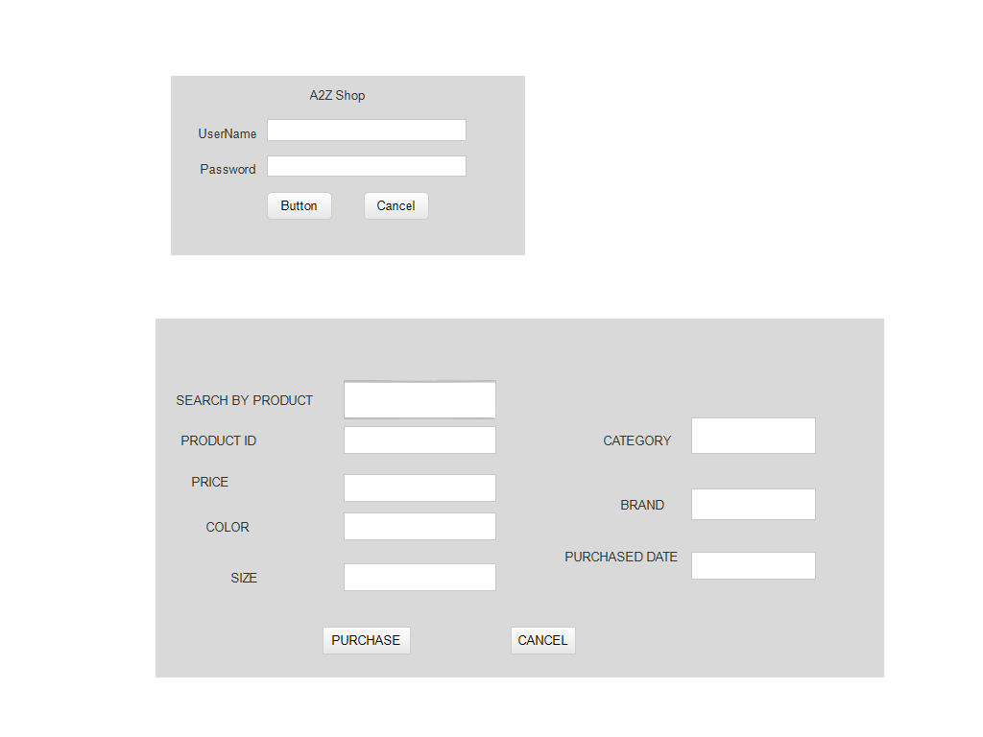

Task (2): Development

-Make customers feel safe in your store

-Ensure that your store shows up in online search results

- Display your local inventory in Google Search and Maps

-Eliminate the wait

-Have a simple loyalty program

-Use product returns to your advantage

-Recognize that retail success doesn’t just come down to just one thing

-Convenience is the biggest perk. Where else can you comfortably shop at midnight while in your nightwear? There are no lines to wait in or cashiers to track down to help you with your purchases, and you can do your shopping in minutes.

**-**Better prices. Cheap deals and better prices are available online, because products come to you direct from the manufacturer or seller without involving middlemen.

-You get to try things on in the comfort of your own home.

Deployment plan

-Server: Install the web application under test. This includes separate web server, database server and application server if applicable.

-Test Tool: The testing tool is to automate the testing, simulate the user operation, generate the test results.

-Network: You need a Network include LAN and internet to simulate the real business and user environment.

-Computer: The PC which users often use to connect the web server.

Task (4)

Functional Testing:

-Unit Testing

-Integration Testing

-Block Box Testing

-White Box testing

Non-Functional Testing:

-Performance Testing

-Load Testing

-Stress Testing

-Usability Testing

-Security Testing

Task (5)

Test Plan:

-Analyse the product of feature you are testing

-Design the test strategies you are going to use

-Define the test objective and pass/fail criteria

-Plan the test environment

-Execute your test plan and track progress in your project management tool

Test data:

-Valid test data. It is necessary to verify whether the system functions are in compliance with the requirements, and the system processes and stores the data as intended.

-Invalid test data. QA engineers should inspect whether the software correctly processes invalid values, shows the relevant messages, and notifies the user that the data are improper.

-Boundary test data. Help to reveal the defects connected with processing boundary values.

-Wrong data. Testers have to check how the system reacts on entering the data of inappropriate format, whether it shows the correct error messages.

-Absent data. It is a good practice to verify how the product handles entering a blank field in the course of software testing.